MED D - Viewing Correspondence and Requesting Reprints in PeopleSafe

Overview
Accessing ONEclick - All Clients
Accessing ONEclick - 12 month Communication History
Accessing ONEclick Directly - Senior Team Only
Using the Find Med D EOB / TF thru 5-2020 Tool
Requesting EOB Reprints
Related Documents

Overview
While the MED D Customer Care Representative (CCR) has the capability to view correspondence with the beneficiary in the Communications History tab, not all correspondence is loaded in this area. When the need arises to view an exact replica of the letter a beneficiary received, the CCR can view the actual letter in one of two tools in the PeopleSafe Inquiry Tab.

Find Med D EOB / TF from 6-2020 tool (ONEclick):
- COB letters (DCOBI, DCOBA, DCOBE, DCOBN)
- ANOC
- EOB from 2016 and later
Note: If the beneficiary has questions about electronic EOBs, refer to MED D - Electronic EOBs or MED D - Blue MedicareRx (NEJE) - Electronic EOBs.
- Formulary
  - Beginning in 2021, the Formulary will only be visible in ONEclick if the beneficiary requested a paper copy of this document. Otherwise, the Formulary will be available on the plan website.

- EGWP Formulary
- EOC
  - Beginning in 2021, EOCs will only be visible in ONEclick if the beneficiary requested a paper copy of this document. Otherwise the EOC will be available on the plan website.
- Dunning Letter #3 (both SSI and NEJE) and effective 07/01/17 - ALL Premium Billing documents
- Transition Fill Letters on or after June 2020.

Notes:
      - For the letter types listed above, refer to Accessing ONEclick - All Clients section. For SSI only, refer to the Accessing ONEclick - 12 month Communication History (SSI Only) section.
      - All Premium Billing documents can also be located by their reference ID in theSource, refer to Aetna MED D - SilverScript - Premium Billing General Information, Processes, & Document Index or MED D - Blue MedicareRx (NEJE) - Premium Billing General Information, Processes, & Document Index.

Find Med D EOB / TF thru 5-2020 tool:
- Transition Fill Letters thru May 2020.
- Negative Formulary Letter
- EOBs from 2015 and earlier
Note: For the letter types listed above, refer to Using the Find Med D EOB / TF thru 5-2020 Tool section

Note: In order to view documents in either tool, a valid Medicare D Member must be in session.

Top of the Document

Accessing ONEclick - All Clients

Perform the following:
Step | Action
1 | Access Member in PeopleSafe
2 | Go to the Tools bar in the Main Screen of PeopleSafe.
3 | Select Find Med D EOB / TF from 6-2020 link.  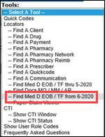  Result: System automatically authenticates and logs the CCR into ONEclick and displays list of available documents.
4 | Select the appropriate member by selecting the View Documents hyperlink.  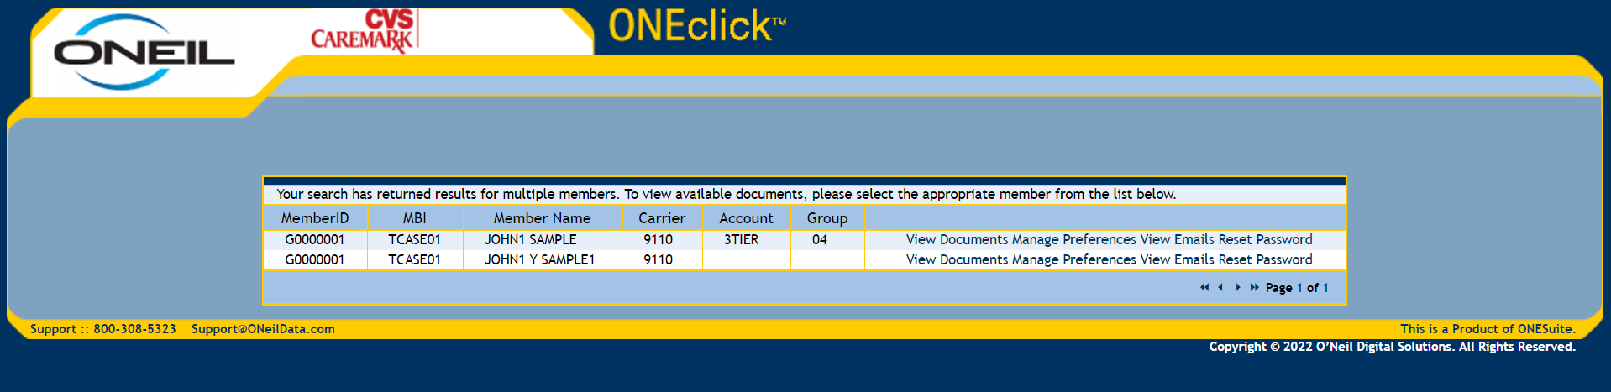  CCR Notes:  - Ensure the correct beneficiary is selected by verifying the line item information in OneClick to PeopleSafe before proceeding to the next step.  - The list may display duplicate beneficiaries (sorted by member name). If duplicate beneficiaries display, any line item can be selected.  - For Manage Preferences, View Emails, and Reset Password refer to MED D - Electronic EOBs or MED D - Blue MedicareRx (NEJE) - Electronic EOBs.  Result: List of communications will display.
5 | Select View from the View Docs drop down list to view appropriate document(s).  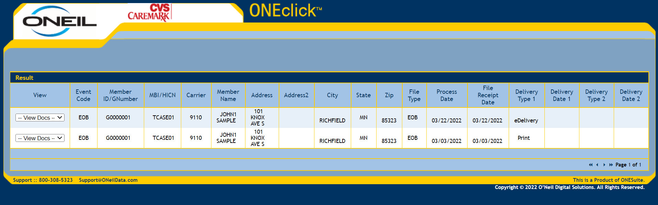  Note: Refer to MED D - TRC Fulfillment Code Index for a list of Event Codes.  Result: A PDF version of the letter will display.  If the CCR needs to access fulfillment history beyond the 12 month communication history provided, the CCR should transfer the call to the Senior Team for assistance. Refer to MED D - When to Transfer Calls to the Senior Team.

Top of the Document

Accessing ONEclick - 12 month Communication History
Note: To view 36 months of Explanation of Benefit (EOB) history, refer to Accessing ONEclick - All Clients.

In order to access the ONEclick database the CCR will:
Step | Action
1 | Authenticate the caller.  Refer to the following documents:  - Caller Authentication  - HIPAA Authentication Grid  CCR Process Note: If the beneficiary cannot be located by Member ID number on the Participant Inquiry tab, the CCR will search for the beneficiary by MBI (Medicare Beneficiary Identifier) in the Medicare D Inquiry tab.  - Exception: Offshore Vendors: If unable to locate by Member ID on the Participant Inquiry Tab, transfer to the Senior Team. Refer to MED D - When to Transfer Calls to the Senior Team and Basic Call Handling.  If the beneficiary experienced an Enrollment issue (i.e. missing information, cancellation of enrollment, denial of enrollment, etc.), this can cause the beneficiary to NOT have a TRUE PeopleSafe account created, therefore, they will NOT be found in the Participant Inquiry tab.  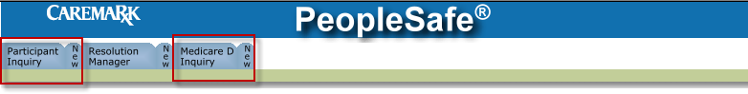  Reminder: If the search on the Medicare D Inquiry tab results in more than one profile, the CCR will select the Active profile.
2 | From the Main screen in PeopleSafe, click on the Medicare D Inquiry tab.  Note: As a default, the Participant Details screen will display.  CCR Process Note: If the beneficiary was NOT found in the Participant Inquiry screen, skip to Step 3.
3 | On the Participant Details screen, click on the Last 12 months of Medicare D Communications hyperlink.  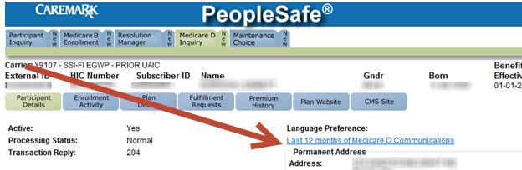  Result: A pop up window will display the ONEclick main screen.  CCR Notes  - Ensure the correct beneficiary is selected by verifying the line item information in OneClick to PeopleSafe before proceeding to the next step.  - The list may display duplicate beneficiaries (sorted by member name). If duplicate beneficiaries display, any line item can be selected.  - For Manage Preferences, View Emails, and Reset Password refer to MED D - Electronic EOBs or MED D - Blue MedicareRx (NEJE) - Electronic EOBs.
4 | Select View from the View Docs drop down list to view appropriate document(s).  Note: Refer to MED D - TRC Fulfillment Code Index for a list of Event Codes.  Result: A PDF version of the letter will display.  Note: The CCR will ask the beneficiary for the reference number that appears in the top right hand corner of the letter they received.  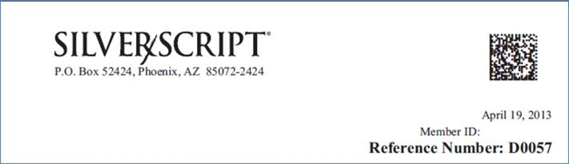  Reminder: Letters can (but not always) also contain reference numbers such as (D00XX).  Resolution Time: Immediate viewing of the document.  Notes:  - To view 36 months of Explanation of Benefit (EOB) history, refer to Accessing ONEclick - All Clients.  If the CCR needs to access fulfillment history beyond what is displayed in OneClick, the CCR should warm transfer the call to the Senior Team for assistance. Refer to MED D - When to Transfer Calls to the Senior Team.
5 | Ask if there are any other benefit questions.
5 | If… | Then…
5 | Yes | - Address any benefit issues  - Document and close the call according to current policies and procedures  - Refer to the MED D - Call Documentation work instruction  Log Activity:  Will vary based on the initial reason for the call  - Refer to the Log Activity Codes Job Aid
5 | No | Document and close the call according to current policies and procedures  - Refer to the MED D - Call Documentation work instruction  Log Activity:  Will vary based on the initial reason for the call  - Refer to the Log Activity Codes Job Aid

Top of the Document

Accessing ONEclick Directly - Senior Team Only

In order to access ONEclick directly (NOT through PeopleSafe or the Medicare D Inquiry tab), the Senior Team Representative will:
Step | Action
1 | Access the following link: https://cvscaremark.memberdoc.com/default.aspx?ReturnUrl=%2fSearch.aspx  Note: If the link will not open from this document or is taking too long, open an internet browser, copy the link into the address field and press the Enter button.  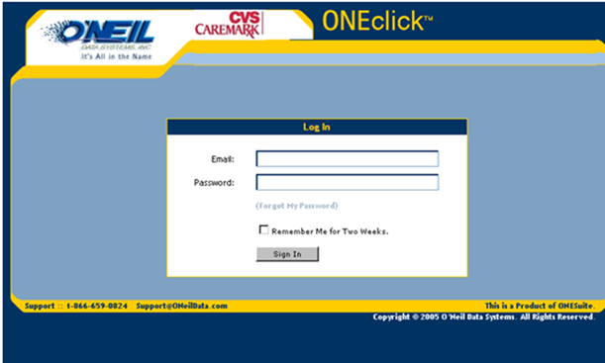  Result: The Login screen will display.
2 | Enter your User Name and Password.  Note: If the Senior Team Representative is having trouble accessing ONEclick, he/she should reach out to a supervisor.  Result: The Correspondence Search screen will display  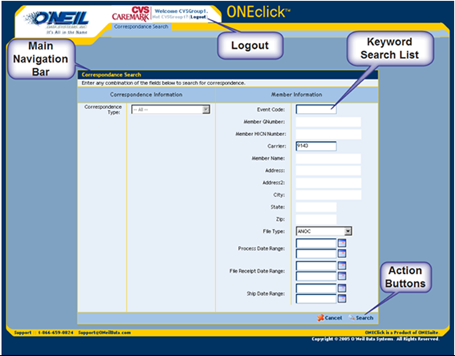
3 | On the right side of the screen, under Member Information, enter the following detail in order to find correspondence information for the beneficiary.  Reminder: The more detail entered the smaller the search results list will be.
3 | Field |  | Data to be entered
3 | Event Code  Note: This is not a search requirement and the CCR will not normally utilize this function |  | Fulfillment within CVS Caremark to describe the various material packets that may be mailed to a Beneficiary.
3 | Member G Number  Note: This is the most common search method used by the CCR |  | The number assigned to the beneficiary for the plan.
3 | Member MBI/HICN Number |  | The beneficiary’s Social Security Administration Number.
3 | Carrier |  | Unique 8-digit ID for clients and their subsets.
3 | Member Name (group contract search only) |  | Any part of the group name can be entered.
4 | Click on the Search button.  Important: Senior Team Representatives should be using the Member ID number (G Number) to search for letters.  Note: The CCR can cancel the search at any time by clicking on the Cancel button.  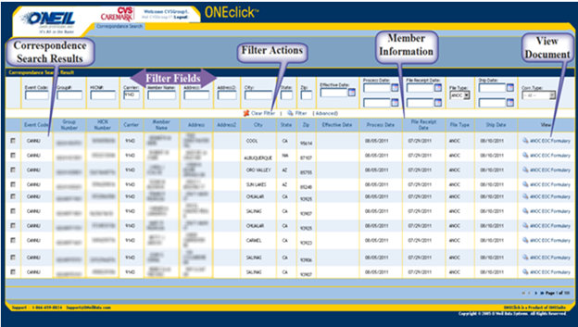  Result: The Correspondence Search Results screen will display populated with data entered on the previous screen.
5 | Locate the appropriate letter/correspondence for the beneficiary.  Note: Refer to MED D - TRC Fulfillment Code Index for a list of Event Codes.  Note: The search results may continue on to another page.  - Use the arrows at the bottom right corner to access the next page
6 | Click on the corresponding hyperlink in the View column in order to view the correspondence.  Note: A new window will open with the document displayed using Adobe Acrobat.  - This can take up to 20 seconds.  - The CCR should ensure that Pop-Ups are allowed or the display window cannot open.
7 | Ask if there are any other benefit questions.
7 | If… | Then…
7 | Yes | - Address any benefit issues  - Document and close the call according to current policies and procedures  - Refer to the MED D - Call Documentation work instruction.  Log Activity:  Will vary based on the initial reason for the call  - Refer to the Log Activity Codes Job Aid
7 | No | - Document and close the call according to current policies and procedures  - Refer to the MED D - Call Documentation work instruction.  Log Activity:  Will vary based on the initial reason for the call  - Refer to the Log Activity Codes Job Aid.

Top of the Document

Using the Find Med D EOB / TF thru 5-2020 Tool
Before attempting to address any MED D issue for a specific client, access the CIF to ensure CVS Caremark Part D Services, LLC is contracted for the specific issue.

Follow the steps below:
Step | Action
1 | Access the MED D account in PeopleSafe.
2 | Click on Tools (drop down).
3 | Click on Find Med D EOB / TF thru 5-2020.  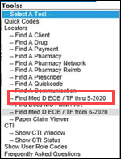  Result: System automatically authenticates and log the CCR into the RR Donnelley Database displaying the search screen.
4 | Paste or input the Member ID. Click Search.  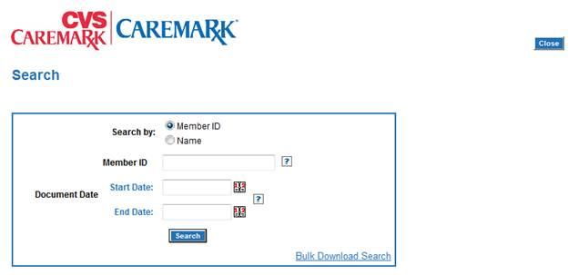  Result: List of available letters display.  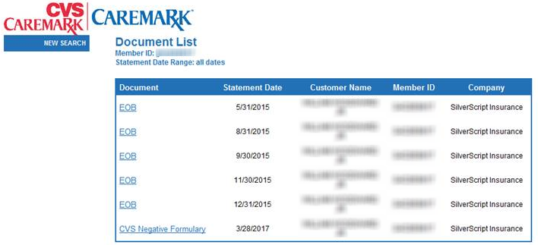
5 | Click on the hyperlink to the desired document to view it.  Result: A PDF version of the letter will display.
6 | Close call and Log as 1308 – EOB Inquiry.

Top of the Document

Requesting EOB Reprints

Follow the steps below:
Step | Action
1 | Access OneClick in PeopleSafe.
2 | Locate and verify the EOB the beneficiary would like reprinted in the document list.  Note: Review the EOB to confirm it contains the claim dates the beneficiary is requesting.  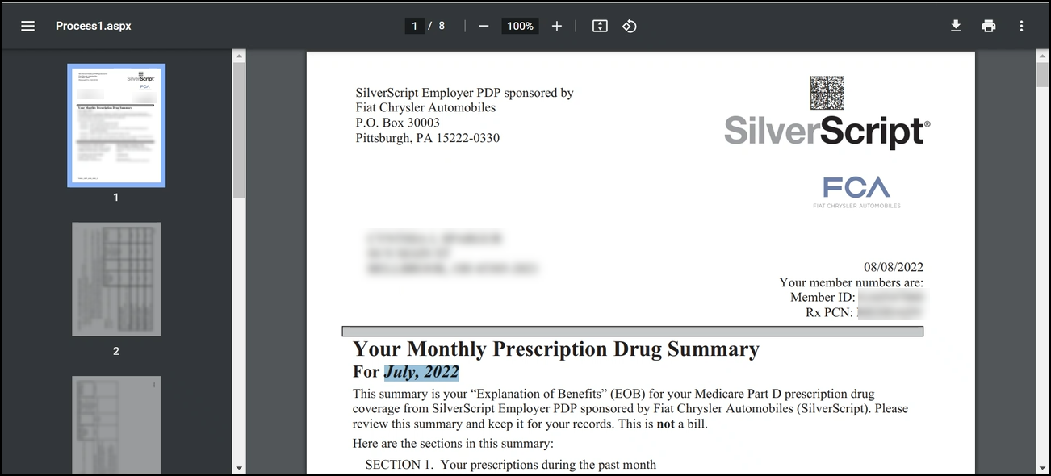
3 | To request a reprint of an existing EOB(s), select the radio button in the Event Code column.  Note: Only one EOB reprint can be selected at a time. If a beneficiary needs multiple EOBs, repeat this process for each EOB.  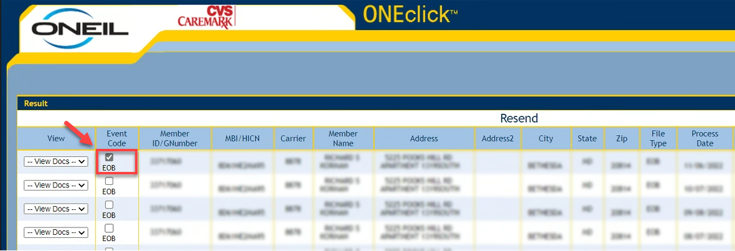
3 | Select Resend.  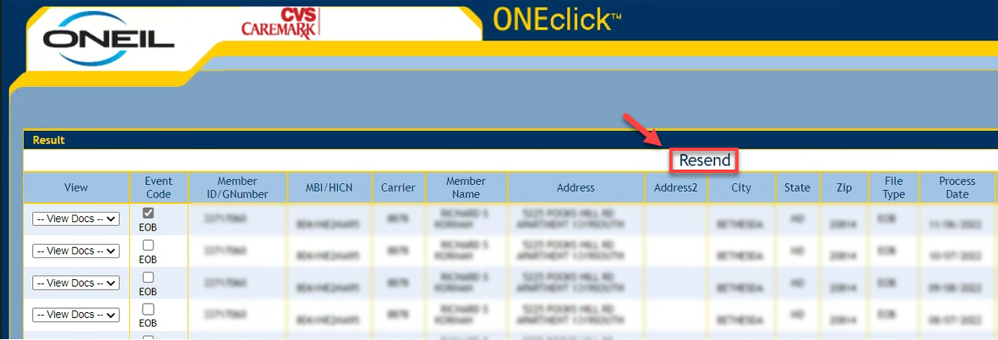
4 | The Confirm Resend Details screen will pop up.  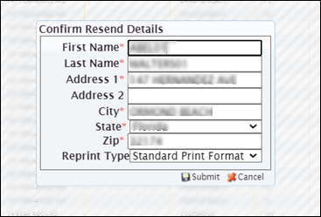
5 | We will request a duplicate copy of the document.  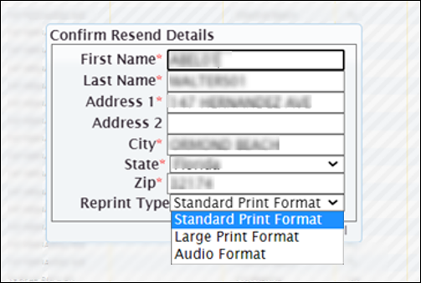  Select Standard Print Format.
6 | Confirm the address the beneficiary would like the EOB reprint mailed to.
6 | If… | Then…
6 | Current address on file | Select Submit to process the reprint.
6 | New address | Is this a temporary address for this EOB reprint only?
6 | New address | If... | Then...
6 | New address | Yes | Update address in Confirm Resend Details screen and click Submit. Document that a one-time address was used for the EOB reprint.  Refer to MED D - Call Documentation Including Viewing and Adding Comments in PeopleSafe.
6 | New address | No | Update address in Confirm Resend Details screen and click Submit and update the address, as appropriate, in PeopleSafe.  Refer to MED D - Address Changes and Out of Area (OOA).
7 | Explain next steps.  You should receive the requested version of your EOB within 20 business days.

Top of the Document

Related Documents
Parent SOP: CALL-0048: Medicare Part D Customer Care Call Center Requirements-CVS Caremark Part D Services, L.L.C.
Abbreviations/Definitions: Abbreviations / Definitions

Top of the Document

Not to Be Reproduced or Disclosed to Others without Prior Written Approval
ELECTRONIC DATA = OFFICIAL VERSION - PAPER COPY = INFORMATIONAL ONLY

